Having trouble reading this email? View it in your browser.
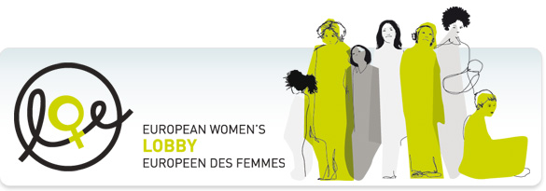
About us | Our work | Publications | News | Press room | Get involved

IN THIS ISSUE  ♦ APPEALS & URGENT ACTIONS  ♦ EWL NEWS  ♦ EUROPEAN & INTERNATIONAL NEWS  ♦ NEW RESOURCES  ♦ EVENTS  ♦ OPPORTUNITIES  HIGHLIGHTS  EWL issues 8 Priorities for the incoming Hungarian Presidency of the EU  [Brussels, 10 December 2010] On 01 January 2011, the Presidency of the Council of the European Union (EU) will pass from Belgium to Hungary. The (...)  read more  EWL calls for action to tackle inequalities in access to healthcare for undocumented migrant women and children  [Brussels, 09 December 2010] On the eve of Human Rights Day 2010 - focusing this year on the theme of ’Human Rights Defenders Who Act to End (...)  read more  We still need your help on maternity leave!  [Brussels, 08 December 2010] On Monday 6 December representatives of national governments meeting in Brussels strongly rebuffed the position of (...)  read more  EU Strategy on Violence against Women - the EC Advisory Committee issues its Opinion  [Brussels, 08 December 2010] The European Commission’s Advisory Committee on Equal Opportunities for Women and Men yesterday adopted its final (...)  read more  Unsubscribe  Click to instantly unsubscribe from this mailing list. | Follow Us on :  APPEALS & URGENT ACTIONS  We still need your help on maternity leave!  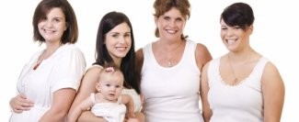  [Brussels, 08 December 2010] On Monday 6 December representatives of national governments meeting in Brussels strongly rebuffed the position of the European Parliament - supported by the EWL - on the so-called ’Maternity Leave Directive’ (see EWL article of 7 December and Parliament Press Release). MEPs on 20 October adopted a Resolution in favour of 20 weeks fully paid maternity leave (...)  read more  Sign the petition for support of child victims of trafficking!  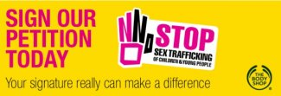  NGOs across Europe and the world have joined forces with The Body Shop to launch a campaign to combat child trafficking. Sign the petition to lobby your government to take action on trafficking and to protect its victims.  Human trafficking is the third largest criminal industry in the world and it is thought that 1.2 million children and young people are trafficked every year. Trafficking is (...)  read more  BACK TO TOP  EWL NEWS  EWL issues 8 Priorities for the incoming Hungarian Presidency of the EU  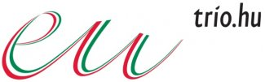  [Brussels, 10 December 2010] On 01 January 2011, the Presidency of the Council of the European Union (EU) will pass from Belgium to Hungary. The European Women’s Lobby (EWL), with more than 2500 member organisations the largest association of women’s organisations in the EU, calls on the Hungarian Presidency to continue to be a driving force for women’s rights in Europe and, in particular, to (...)  read more  EWL calls for action to tackle inequalities in access to healthcare for undocumented migrant women and children  [Brussels, 09 December 2010] On the eve of Human Rights Day 2010 - focusing this year on the theme of ’Human Rights Defenders Who Act to End Discrimination’ - the EWL co-organised a Public Hearing in the European Parliament to help raise awareness on the issue of inequalities in access to health care services for undocumented migrants - including pregnant women and children - in many EU (...)  read more  Cyprus - MIGS calls on government to support strong EU maternity leave provisions  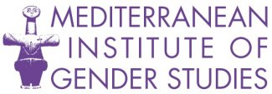  [Brussels, 9 December 2010] EWL member organisation in Cyprus, the Mediterranean Institute for Gender Studies (MIGS) has issued a Press Release expressing disappointment at the outcome of this Monday’s social affairs Council meeting in Brussels when ministers rejected a legislative proposal of the European Parliament giving 20 weeks fully paid maternity leave tor new mothers and 2 weeks to (...)  read more  NGO Coalition on Intergenerational Solidarity welcomes EPSCO decision to declare 2012 European Year for Active Ageing and Solidarity between Generations  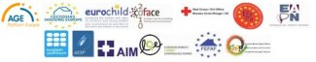  [Brussels, 8 December 2010] We are pleased that the EPSCO Council supported our call and has decided to extend the title for the proposed European Year 2012 to “Active Ageing and Solidarity between Generations”.  We welcome the objectives of the Year, i.e. “to encourage and support the efforts of Member States, their regional and local authorities, social partners, civil society and the business (...)  read more  Way Cleared for EU to Join Human Rights Treaty  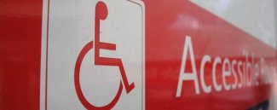  [Brussels, 06 December 2010] EWL member organisation the European Disability Forum (EDF) has issued a joint press release together with Human Rights Watch celebrating the agreement by the Council to a Code of Conduct that will allow the EU to accede to the Disability Rights Convention and ensure implementation in all EU countries.  PRESS RELEASE - The European Disability Forum & Human (...)  read more  BACK TO TOP  EUROPEAN & INTERNATIONAL NEWS  Human Rights Day 10 December 2010: Human Rights Defenders Who Act to End Discrimination  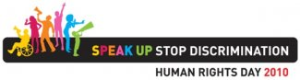  [Brussels, 10 December 2010] The theme of Human Rights Day this year is ’Human Rights Defenders Who Act to End Discrimination’. Discrimination against women is the most widespread form of discrimination within societies worldwide. As UN High Commissioner for Human Rights, Navi Pillay, notes in her Statement copied below, 70% of those who are denied basic education worldwide are girls. Today the (...)  read more  EU Strategy on Violence against Women - the EC Advisory Committee issues its Opinion  [Brussels, 08 December 2010] The European Commission’s Advisory Committee on Equal Opportunities for Women and Men yesterday adopted its final Opinion on an EU Strategy on Violence against Women and Girls. Over the last six months, the EWL has taken a very active role within the expert Working Group chaired by Andrea Murray from the UK Equality and Human Rights Commission, and is very pleased (...)  read more  Maternity leave: Council disregards Parliament’s position  [Brussels, 07 December 2010] European ministers for social affairs meeting yesterday in Brussels took a strong stand against the Parliament’s position on the ’Maternity Leave Directive’, disappointing the EWL and MEPs, who have criticised the Council for ignoring the new role of the Parliament as precribed by the Lisbon Treaty.  Press Release from the European Parliament Committee for Women’s (...)  read more  BACK TO TOP  NEW RESOURCES  - European Commission Newsletter- DG Research - unit Scientific culture and gender issues (December 2010)  - AWID - Towards a Future without Fundamentalisms: Religious Fundamentalist Strategies and Feminist Responses (2010)  - NEWW Poland - South Baltic - Violence free project report (September 2010)  - European Parliament Platform for Secularism in Europe - website  - Cordaid & GNWP - Costing and Financing Implementation of UNSCR 1325 (2010)  - Stephanie Ortoleva - Women with Disabilities: The Forgotten Peace Builders  - Global Fund for Women - Another World Is On Her Way: Annual Report 2009-10  - The Fatherhood Institute - The Fatherhood Report 2010-11: The Fairness in Families Index  BACK TO TOP  EVENTS  - Conference: Le deuxième sexe de l’immigration: Bruxelles, 17 décembre 2010  BACK TO TOP  OPPORTUNITIES  - Reminder: Registration for NGO Events during CSW 55 (Deadline: 13 December 2010)  - “Naming and Framing: The Making of Sexual (In)Equality”  - Chargé/e de développement, CLEF (10 décembre 2010)  BACK TO TOP
18 RUE HYDRAULIQUE - 120 BRUSSELS / BRUXELLES - BELGIUM / BELGIQUE - T (+32) 02/217 90 20 F (+32) 02/219 84 51
EWL@WOMENLOBBY.ORG - WWW.WOMENLOBBY.ORG

Editeur : European Women’s Lobby Européen des femmes
http://www.womenlobby.org

Cliquez ici pour modifier votre abonnement

